Regenerative Organic Certified
Written comments on the certification draft
Comment #1: The addition of a fourth pillar for human health and societal health improvement.
The Three Pillars do not address human health and regenerative health of the human diet. I suggest that we address the concerns that Mr. Rondell talks about in chapter 17, of the Complete Book of Composting. The Merc Report for July 1949 addresses soil studies and their health implications, which were identified, at the turn of the 19th century. At that time, our society’s ability to address these concerns were limited by their farm implements, the ability to test bioavailability from specific mineral applications and the availability of clean refined minerals.
The inability to address these problems 100 years ago has led us to a pharmaceutical nightmare we are coping with today. The consumption of organic foods still require most of us to supplement our diets with a chemical compound, such as a mineral supplement or vitamin because our foods do not deliver the vitamin or mineral nutrients we need. We can address this problem further down the road, or we can correct it now with this certification. This problem can only be corrected by adding this pillar of human health improvement.
Comment #2: To address the heavy metal contamination in our food system, often present in the plant foods we consume, including those certified as organic.
Arsenic, mercury, cadmium, and lead should be regulated by this certification. The testing requirements to identify the parts per billion of these minerals have now been standardized by Activation Labs, in Canada. A copy of their testing protocol is attached. The NSF standards for raw products have also been established. At a minimum, we should be able to meet or achieve these standards. They are arsenic at less than 5000 ppb; cadmium, less than 300 ppb; mercury, less than 200 ppb; and lead, less than 10,000 ppb.
If our standard is to set the bar higher, I suggest the following grading system. See attached below.
http://www.actlabs.com/files/Actlabs_-_Schedule_of_Services_-_International_-_2016-10-19.pdf
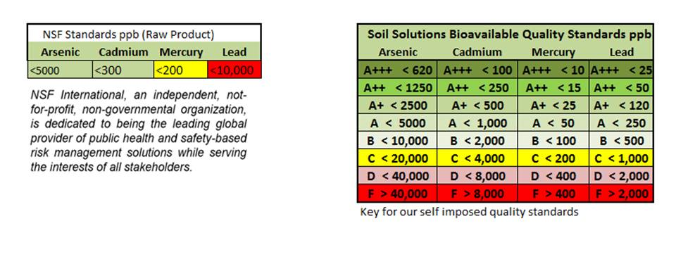

Currently the Health Ranger of Texas has adopted a standard similar to this and is constantly identifying organically certified products that score below the F listing of the standard. I truly believe we have the capability to properly address arsenic and mercury, as described Rodale's book. We need to identify the problem, and the current organic certification does not address this problem.
Comment #3: To address mineral deficiencies in the plant tissue of food.
The Dr. James Duke database, which is a USDA.gov database, https://phytochem.nal.usda.gov/phytochem/search
is used to properly identify plants and their ability to absorb bioavailable minerals from the soil. I believe it is important to ensure that the quality of our food maintains the bioavailable minerals needed to support good health in both human consumption and animal consumption. I am proposing we utilize the Dr. James Duke database as a guide to identifying soil depletion and bioavailable mineral correction if indicators for plant tissue test identify deficiency.
To clarify this point, here is an example using this database. The following are two of the minerals identified in lettuce from the database:
The Lettuce plant is capable of accumulating 20 ppm of chromium on the high end and .005 ppm on the low end.
The Lettuce plant is capable of accumulating .87 ppm of cobalt on the high end and .002 ppm on the low end.

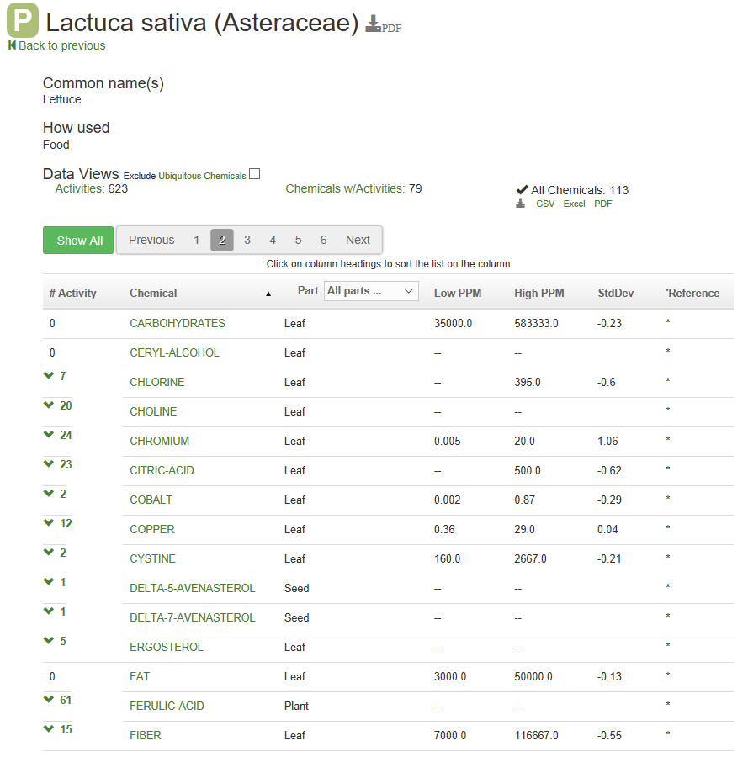

I recommend that this organic certification incentivize maintaining greater than the 50th percentile of the minerals identified as having a beneficial chemical activity. According to the usda.gov database, the following minerals have a beneficial activity: lithium, boron, sodium, magnesium, silicon, phosphorus, sulfur, chlorine, potassium, calcium, vanadium, chromium, magnesium, iron, cobalt, nickel, copper, zinc, selenium, molybdenum, silver, iodine, and gold.
All of these minerals have a beneficial effect on human health and, whenever possible, the bioavailability of minerals in food should be addressed whenever the plant tissue indicates the lack thereof. The testing for plant tissue bioavailability has been standardized by Activation Laboratories. These tests are available to the general public at an economical price. See the link below. In addition, this lab provides securities and exchange third-party certified reports with all standardized test.
http://www.actlabs.com/files/Actlabs_-_Schedule_of_Services_-_International_-_2016-10-19.pdf

Comment #4: The addition of the following products to acceptable organic products list, for this certification.
Under the current organic regulations, amending the soil requires the soil test demonstrates the need for the addition of the soil amendments. I believe this practice is flawed because it does not indicate true bioavailability for the plant. For this reason, I am suggesting the addition of the following products and any other products that can show an increased bioavailability of minerals to the plant, without the use of GMOs or other plant manipulation. In addition, the soil amendments must have the purity to ensure no pesticides or herbicides have been added. All products added to this list will also be able to demonstrate increased bioavailability through a certified lab plant tissue uptake test. Products with heavy-metal contamination must not increase the plant tissue uptake to any significant level. That standard has yet to be determined, as proposed in comment number two.
The following are Western Environmental Services, Soil Solutions products we are requesting to be added to the acceptable conditioners list.
MEMORY FORMULA
Soil Conditioner Product #021454 Designed to replenish selective minerals into your garden to help with memory. These mineral deficiencies may be associated with memory symptoms: Magnesium, Boron, Cobalt, Selenium, Yttrium and Sulfur.
GLUCOSE TOLERANCE FACTOR FORMULA
Soil Conditioner Product #021209 Designed to replenish selective minerals into your garden to help with glucose tolerance issues and diabetes. These mineral deficiencies may be associated with diabetes or other glucose tolerance issues: Chromium, Vanadium, Molybdenum, Zinc, Sulfur and Potassium.
EMOTIONAL WELL-BEING FORMULA
Soil Conditioner Product #021393 Designed to replenish selective minerals into your garden to help improve your overall emotional well-being. These mineral deficiencies may be associated with depression and emotional instability: Boron, Calcium, Magnesium, Selenium, Lithium and Sulfur.
FERTILITY & POTENCY FORMULA
Soil Conditioner Product #021396 Designed to replenish selective minerals into your garden to help with fertility or impotency issues. These mineral deficiencies may be associated with fertility or impotency issues:
Impotence: Selenium, Zinc, Manganese, Calcium, Chromium, Iodine, or Sulfur.
Infertility: Calcium, Zinc, Selenium, Chromium, Copper, Cobalt, Manganese, Iodine, or Sulfur.
HEART HEALTH FORMULA
Soil Conditioner Product #021395 Designed to replenish selective minerals into your vegetable garden to help improve your cardiovascular system. These mineral deficiencies may be associated with heart and cardiovascular conditions: Calcium, Manganese, Magnesium, Selenium, Copper, and Sulfur.
HEALTH & IMMUNE SYSTEM FORMULA
Soil Conditioner Product #021394 Designed to replenish selective minerals into your garden to help those with symptoms of a weakened immune system. These mineral deficiencies may be associated with a weakened immune system: Boron, Iodine, Magnesium, Silver, Zinc, Tin and Sulfur.
Comment #5: The addition of sodium thiosulfate for acceptable use as a soil amendment.
Sodium thiosulfate is currently banned on the organic list under the following two conditions: as a pesticide, or as a food preservative. Using this oxidized sulfur compound as a soil conditioner or part of a soil conditioner allows delivery of oxygen to the microbes in the soil in areas where compaction, in
no-till conditions, exists. Sulfur and oxygen from this formula is capable of providing nutrition to the microbes in anoxic areas of the soil and is capable of dissolving minerals for the plant uptake in this form. Sodium thiosulfate is also capable of reducing hexavalent cancer-causing chromium to a non-toxic trivalent chromium form. This reduction is also seen in other toxic minerals, such as hexavalent platinum, a residual contaminant of chemotherapy.
Oxidized sulfur also plays an important role in the movement of minerals within the soil. Oxidized sulfur is capable of bonding minerals and preventing them from coming out of solution or plating onto other minerals within the soil.
Comment #6: To allow reagent or technical grade minerals to be used as soil amendments.
As described in comment number four, bioavailable minerals are important and should be delivered in a cleaner form than current fertilizer grade minerals. I am suggesting the following mineral elements be listed as acceptable refined, reagent, or technical grade products for use in soil conditioners and soil amendments: lithium, boron, sodium, magnesium, silicon, phosphorus, sulfur, chlorine, potassium, calcium, vanadium, chromium, magnesium, iron, cobalt, nickel, copper, zinc, selenium, molybdenum, silver, iodine, and gold.
Comment #7: The addition of value-added soil building.
It has been obvious that organic foods are lacking the ability to increase their nutrient value under the current organic guidelines. It is important that we identify organic methods that will improve the mineral content of our foods through the soil. This organic certification should encourage livestock operations that are supplementing their livestock with minerals to recover and utilize the manure for its mineral content that the livestock have not absorbed. I believe the certification should be mindful of every opportunity to increase the mineral density of both cattle feed and human food. The testing of these manures should include a mineral bioavailability plant tissue test in order to ensure that the other feeds integrated into the cattle operation are not causing harm to the animals or the environment.
Comment #8: To address foods grown in soil, in container gardens.
Soil conditioners designed for bioavailable uptake require the use of containers to maintain the mineral consistency within the plant. Minerals applied to the ground are more susceptible to erosion and soil depletion, which makes use of these conditioners impractical and unsustainable. To address the use of containers, within this regulation I suggest the following:
Bi-annual water samples from the watering system to ensure minimal contamination of the soil from the following minerals: Mercury, arsenic, cadmium, lead and fluoride. All of these minerals are capable of bioavailable loading within the food and should be addressed within this regulation. A growing operation that is watering with fluoridated water should be mandated to remove the fluoride by using a filtration system.
Comment #9: The addition of recyclable materials, utilized in container gardens.
Whenever possible, containers for these garden systems should be manufactured from 50% or greater recyclable materials.

http://www.actlabs.com/files/Actlabs_-_Schedule_of_Services_-_International_-_2016-10-19.pdf
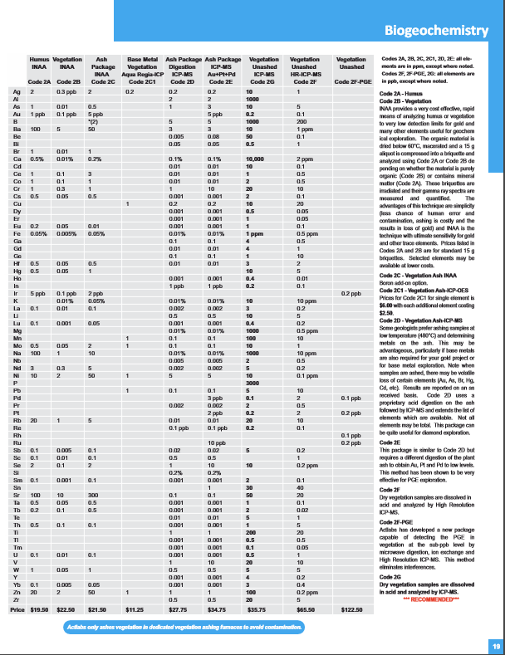
http://www.actlabs.com/files/Actlabs_-_Schedule_of_Services_-_International_-_2016-10-19.pdf

